Version 1.0
12/10/2019

Alan DUFFIN
X00159409
cERTIFICATE, CLOUD SOLUTIONS ARCHITECTURE 2019, PROJECT

feasibility and refined research plan

Table of Contents

PROJECT BACKGROUND AND DESCRIPTION 3
PROJECT DESCRIPTION 4
PROJECT USECASE 6
PROJECT DELIVERABLES 9
TECHNICAL AREAS OF INVESTIGATION 10
TECHNICAL REQUIREMENTS AND COSTS 12
PROJECT TIMELINES 13
RISKS AND ISSUES MANAGEMENT 14
RISK MITIGATION 14
REFERENCE LIST AND BIBLIOGRAPHY 15

PROJECT BACKGROUND AND DESCRIPTION

Workflow is a common pattern for solving use cases across a broad range of sectors. These use cases require maintaining state and coordinating operations across sometimes heterogeneous / distributed participants over extended time periods. Examples of common problem areas include loan/insurance origination, order management, billing systems and logistics fulfilment.
These systems have a common problem set that must be solved. The workflow pattern must address requirements such as state transition, error handling, component / service integration and human interaction/decision making.
Many vendors have designed solution frameworks around the concept of the Finite State Machine such as BPEL (Business Process Execution Language). The growth of SaaS and Paas platforms has allowed users to take advantage of fully managed, scalable services for many problem domains including workflow.
My project proposal is to research the available Workflow/Servlerless services that are available from the three largest SaaS Cloud providers: Google Cloud, Amazon Web Services, Microsoft Azure. I will subsequently create a comparison matrix for these SaaS platforms based on a set of required criteria for the Workflow use case that is to be implemented. This matrix will be used to select a Cloud vendor platform upon which to implement the use case. Some of these criteria/features are:
- Features
- Ease of use
- Latency
- Cost
- Maintainability / Trobleshooting
- State Maintenance / Error Handling.

PROJECT DESCRIPTION
Loan origination is the process by which a borrower applies for a new loan, and a lender processes that application. Origination includes all the steps from taking a loan application up to drawdown of funds or refusal of the application.
The loan origination process has many steps, including:
- Loan application — The homebuyer fills out a loan application form.
- Documents — The buyer submits documentation for income, employment and financial status.
- Underwriting — The lender reviews the loan application, verifies the buyer’s credit and determines if the buyer’s income and financial status is such that the buyer qualifies for the loan.
- Finalise loan application — Once the terms are agreed on, the loan application is processed by the lender, going through several departments, such as underwriting and documentation processing.
- Loan approval — After final processing, the lender decides to approve or reject the loan application.

The Lifecycle of a Homeloan Application
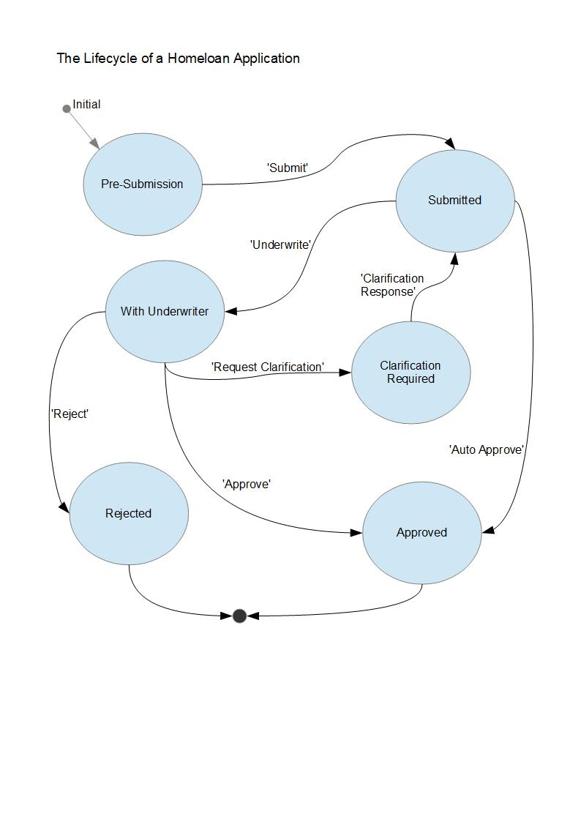

PROJECT USECASE

Human Actors
Branch Staff | Actor 1
Broker | Actor 2
Customer | Actor 3
Underwriter | Actor 4

The Bank Branch Staff Member or Broker (Actor 1) via the user interface will view the list of active Loan Applications.
- Actor 1 can choose to view the details of any individual Loan Application.
- Actor 1 can create a new Loan Application on behalf of a customer.
- Actor 1 can input all required customer and loan details.
- After reviewing all information Actor 1 can submit the Loan application into the Approvals workflow. This should initiate a workflow execution.
- Possibly notifications should be sent to all human actors of loan application state changes. This could be via email, or a front end notification.
- The workflow execution should consist of the steps shown in the table below (not exhaustive).

Step Number | Workflow Component
1 | Validate that all mandatory data has been input for the Approval process
2 | Run the affordability calculator and validate that the case does not fall outside loan rules e.g. age of applicants, loan term, unsuitable employment, not in current employment for long enough etc.
3 | Decision rule to either auto approve or route the application to an Underwriter (Actor 2) for human review.
4 | The Auto Approval service will mark the application as approved and notify Actor 1. (Notification method unknown at the moment)
5 | The Underwriters have discretion to approve the loan application based on extenuating circumstances such as Junior doctor with immediate prospects of salary increases and stable job prospects.
6 | If manual Approval is required the workflow will notify Actor 4 that the Loan Application is awaiting review and pause execution.
7 | Actor 4 must open the Loan Application and review details.
8 | Actor 4 can then choose to Approve or Decline the application. This is done via the front end and calls a service that restarts the workflow execution.
9 | The workflow will then notify Actor 1 and the Customer (Actor 3) using some mechanism.
10 | The workflow will terminate.

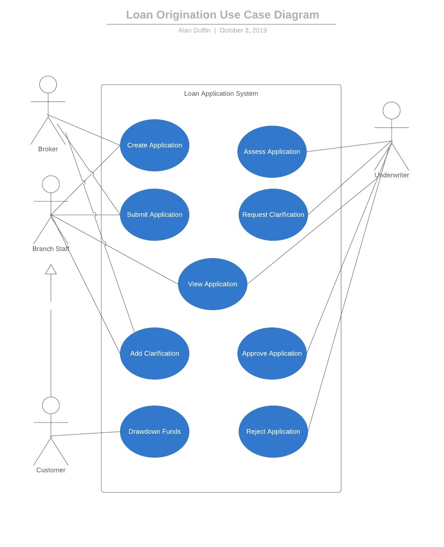

PROJECT DELIVERABLES

Key Deliverables | Interim Deliverables | Date Due
Initial Research Proposal |  | 6th October
Feasibility and Research Project Plan |  | 13th October
Literature Review/Research |  | 20th October
Technology Research and Development |  | 27th October
Project Implementation | Iteration 1 | 10th November
 | Iteration 2 | 24th November
 | Final Iteration | 8th December
Final Report and Presentation |  | 15th December

TECHNICAL AREAS OF INVESTIGATION

The following table lists the PaaS services that will be required to implement a solution for my project use case.

SaaS Provider | Services for Investigation
Google Cloud | Cloud Composer.  Apache Airflow.  Cloud Functions.  Cloud Pub/Sub.  Cloud Datastore.
Microsoft Azure | Logic Apps.  Microsoft Flow.  Azure Functions.  Event Grid.  Queue Storage.  CosmosDB.
Amazon Web Services | Step Funtions.  Lambda.  SNS.  SQS.  DynamoDB.

The most important services for research are obviously the workflow/orchestration PaaS services that are provided by Google Cloud Platform, AWS and Azure. These services are Google Orchestrator, AWS Step Functions and Azure Logic Apps.

Cloud Composer is a hosted solution for the open source Apache Airflow platform. It is based on a Directed Acyclic Graph which is slightly different that a State Machine that does allow cycles. It supports a hybrid cloud or multi vendor solution. Only the Python development language is supported.

AWS Step Functions provides a serverless orchestration solution. Step Functions provides pre build steps that implement basic primatives to speed development and improve reliability and reuse. Step Functions also integrate out of the box with other AWS services. It can also support a hybrid cloud model.

The Azure Logic Apps service was designed specifically by Microsoft to allow non-developers to design and build Workflows in the cloud. Logic Apps benefits from a library of hundreds of pre-built Connectors to integrate with existing Azure Services. Logic Apps also support the hybrid cloud model by allowing the connection of distributed systems across on-premises and in-cloud environments.

My research into these services will focus on criteria that will allow speed to market, ease of use, cost, ease of maintainance and diagnostic tools. Ideally the service should have out of the box support for integration with the cloud vendor NoSQL database, Notification service, Servlerless components and Queue services. The initial research should estimate the usage statistics for the application in terms of throughput, storage, fixed costs. The cloud vendor Cost Calulators will then be used to estimate the cost of deployment and running the application for the remainder of the year. Should any of the Cloud vendors prove to be outliers in terms of costs that may prove to be a deciding factor in the ultimate selection decision.

TECHNICAL REQUIREMENTS AND COSTS

In order to build and test prototypes to investigate PaaS services associated with the project use case, I will require an account with each of the three Cloud vendors that are under investigation.

I will also require a local software development environment on my laptop. The three vendors do not all support a common set of programming languages for each of the services that I will be using. The only common language available seems to be Javascript. I will require a Javascript / NodeJS development environment.

Google Cloud Platform, AWS and Azure all have different pricing models even for equivalent services.
Google Cloud Platform and Azure both provide a credit voucher when customers initially subscribe. AWS provide a 12 month period where services are available for free but subject to usage limits.

Azure provide 170 euro free credit and Google Cloud Platform provide $300 credit upon subscription.

The pricing structure for the services that are under investigation for this project are as follows:

 | AWS | Azure | Google
Workflow | 4,000 free state transitions p/m. First year | €0.000022 per execution. | $280 p/m approx
Servlerless | 1 M Requests free p/m | 1 M Requests free p/m | 2 M Requests free p/m
Queue Service | 1 M Requests free p/m | 100K operations free p/m | 10GB free p/m
Database | 25GB free p/m  200M requests free p/m | 5-GB and 400 RUs provisioned throughput first year. | 1 GB free p/d  50K Reads/20K writes p/d

PROJECT TIMELINES

 | Tasks | Dates
Literature Review | Amazon Web Services | Sun 13th - 20th Oct
 | Microsoft Azure
 | Google Cloud Platform
Technology Assessment | Amazon Web Services | Sun 20th - 27th Oct
 | Microsoft Azure
 | Google Cloud Platform
Implementation Iteration 1 | Create Database Schema.  Implement Database CRUD code.  Implement / Test Individual Services using Serverless functions and REST API. | Sun 27th Oct - 10th Nov
Implementation Iteration 2 | Create initial Workflow orchestration and tasks.  Integration testing with services from Iteration 1. | Sun 10th - 24th Nov
Implementation Iteration 3 | Create / Test User Interface.  Create / Test Nofication mechanisms for Human actors.  Final integration testing | Sun 24th Nov - 8th Dec
Prepare Final Report |  | Sun 8th^{th} - 15th Dec

RISKS AND ISSUES MANAGEMENT
- The Moodle Project schedule prescribes one week for Literature Review and one week for R & D of all the required services across the 3 cloud vendors. I do not believe this to be achievable.
- To build a fully functional project implementation will require a combination of many services. For example, if implemented on AWS these would include SNS, SQS, Lambda, S3, API Gateway. A browser-based frontend will be required to allow user interaction. This would require significant software development using HTML, javascript, etc perhaps using AWS frameworks such as ASW Amplify, Cognito, IAM. There is a risk that the software development effort may not be achievable in the allotted timeframe.
- Design/Architecture lacks flexibility, is not fit for purpose or is infeasible.
- Estimates are inaccurate perhaps due to scope creep or required activities are missing from scope.
- Learning curves lead to delays because developer is inexperienced.
- Requirements are incomplete or fail to align with available systems/services.User interface doesn't allow users to complete tasks or is low quality.

RISK MITIGATION

The core functionality for this project is to implement a workflow orchestration for the mortgage origination use case. The individual services that need to be developed will be done on a Servlerless platform. The applicatoin data will be stored on a NoSQL managed cloud database. The services will be exposed via HTTP endpoints. Ideally there would also be a web based front end to allow a user friendly interface coupled with appropriate Authentication and Authorisation controls. However, due to project deadlines this front end which is not part of the core Workflow research may be ommitted.

REFERENCE LIST AND BIBLIOGRAPHY

Cloud Services FAQs
Google Cloud, Composer. https://cloud.google.com/composer/ (10 Oct, 2019)
Apache Airflow. https://airflow.apache.org/ (10 Oct, 2019)
Google Cloud, Functions. https://cloud.google.com/functions/ (10 Oct, 2019)
Google Cloud, Pub/Sub. https://cloud.google.com/pubsub/docs/ (10 Oct, 2019)
Google Cloud, Datastore. https://cloud.google.com/datastore/ (10 Oct, 2019)

Azure, Logic Apps. https://azure.microsoft.com/en-us/services/logic-apps/ (11 Oct, 2019)
Azure, Functions. https://azure.microsoft.com/en-us/services/functions/ (11 Oct, 2019)
Azure, Event Grid. https://azure.microsoft.com/en-us/services/event-grid/ (11 Oct, 2019)
Azure, Queue Storage. https://azure.microsoft.com/en-us/services/storage/queues/ (11 Oct, 2019)
Azure, ComosDB. https://docs.microsoft.com/en-us/azure/cosmos-db/introduction/ (11 Oct, 2019)

AWS, Step Functions. https://aws.amazon.com/step-functions/ (12 Oct, 2019)
AWS, Lambda. https://aws.amazon.com/lambda/ (12 Oct, 2019)
AWS, SNS. https://aws.amazon.com/sns/ (12 Oct, 2019)
AWS, SQS. https://aws.amazon.com/sqs/ (12 Oct, 2019)
AWS, Dynamo DB. https://aws.amazon.com/dynamodb/ (12 Oct, 2019)

Cloud Services Pricing

Google Cloud, Composer. https://cloud.google.com/composer/pricing/ (10 Oct, 2019)
Google Cloud, Functions. https://cloud.google.com/functions/pricing/ (10 Oct, 2019)
Google Cloud, Pub/Sub. https://cloud.google.com/pubsub/pricing/ (10 Oct, 2019)
Google Cloud, Datastore. https://cloud.google.com/datastore/pricing (10 Oct, 2019)
Google Cloud, Free Limits. https://cloud.google.com/free/ (10 Oct, 2019)

Azure, Logic Apps. https://azure.microsoft.com/en-us/pricing/details/logic-apps/ (11 Oct, 2019)
Azure, Functions. https://azure.microsoft.com/en-us/pricing/details/functions/ (11 Oct, 2019)
Azure, Event Grid. https://azure.microsoft.com/en-us/pricing/details/event-grid/ (11 Oct, 2019)
Azure, Queue Storage. https://azure.microsoft.com/en-in/pricing/details/storage/queues/ (11 Oct, 19)
Azure, ComosDB. https://azure.microsoft.com/en-us/pricing/details/cosmos-db/ (11 Oct, 2019)
Azure, Free Limits. https://azure.microsoft.com/en-us/free/#new-products

AWS, Step Functions. https://aws.amazon.com/step-functions/pricing/ (12 Oct, 2019)
AWS, Lambda. https://aws.amazon.com/lambda/pricing/ (12 Oct, 2019)
AWS, SNS. https://aws.amazon.com/sns/pricing/ (12 Oct, 2019)
AWS, SQS. https://aws.amazon.com/sqs/pricing/ (12 Oct, 2019)
AWS, Dynamo DB. https://aws.amazon.com/dynamodb/pricing/provisioned/ (12 Oct, 2019)
AWS, Free Limits. https://aws.amazon.com/free/

